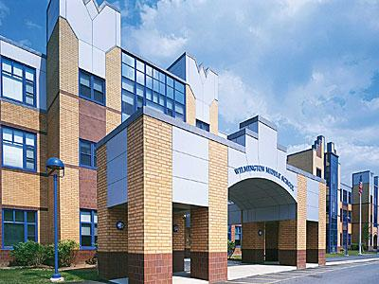
Wilmington Middle School PAC Meeting
Agenda
~ February 25,2020 @6:30pm ~
2019-2020 PAC Officers
Heather Long - President – heatherdlong77@gmail.com
Jen Jackson - Vice President - joejenjackson@gmail.com
– Treasurer –
Lisa D’Anna – Secretary – lldanna@verizon.net
- Publicity Coordinator -

- Welcome/Introductions

- Principal’s Report - Mr. Phillips

PAC Business:
- Treasurer’s Report (Heather Long, interim treasurer)
- Teacher Appreciation update (Jen Jackson)
- Box Tops Update (Heather)
- ELA Books Update (Heather)
- Spring Apparel Sale
- Hand sanitizers (cafeteria)

Open Discussion:

The next PAC Meeting will be March 24, 2020 at 6:30 pm

