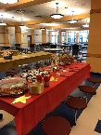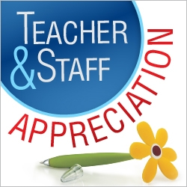

Every parent or guardian of a Middle School student is already a member of the PAC (Parent Advisory Council) and you can be as involved as you wish. The PAC is a fun, relaxed and comfortable atmosphere in which we will discuss important and current school events, issues, programs and fundraisers. All funds raised help to support student enrichment, parent workshops, staff appreciation events, as well as various other school needs like supplies and technology. This year the PAC used a direct donation campaign as the sole means of fundraising. This quick and easy (either online or by check) way to donate hopefully eliminated some of the stress of catalog fundraising and provided parents with an easy way to give back to the schools. Please visit the school website, the Wilmington Middle School PAC page on Facebook, or email ***wilmMSPAC@gmail.com*** for more details.

**What is the WMS PAC?**

Wilmington Middle School PAC

|  |  |
| --- | --- |
|  |  |

For the 8th Grade Semi-Formal dance the PAC will be sponsoring a

Photo Booth

so the students can have some fun pictures of the night!

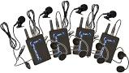

This year, the PAC helped to purchase

some new microphones for the Middle

School Drama Club. In the past, they

had borrowed from the High School.

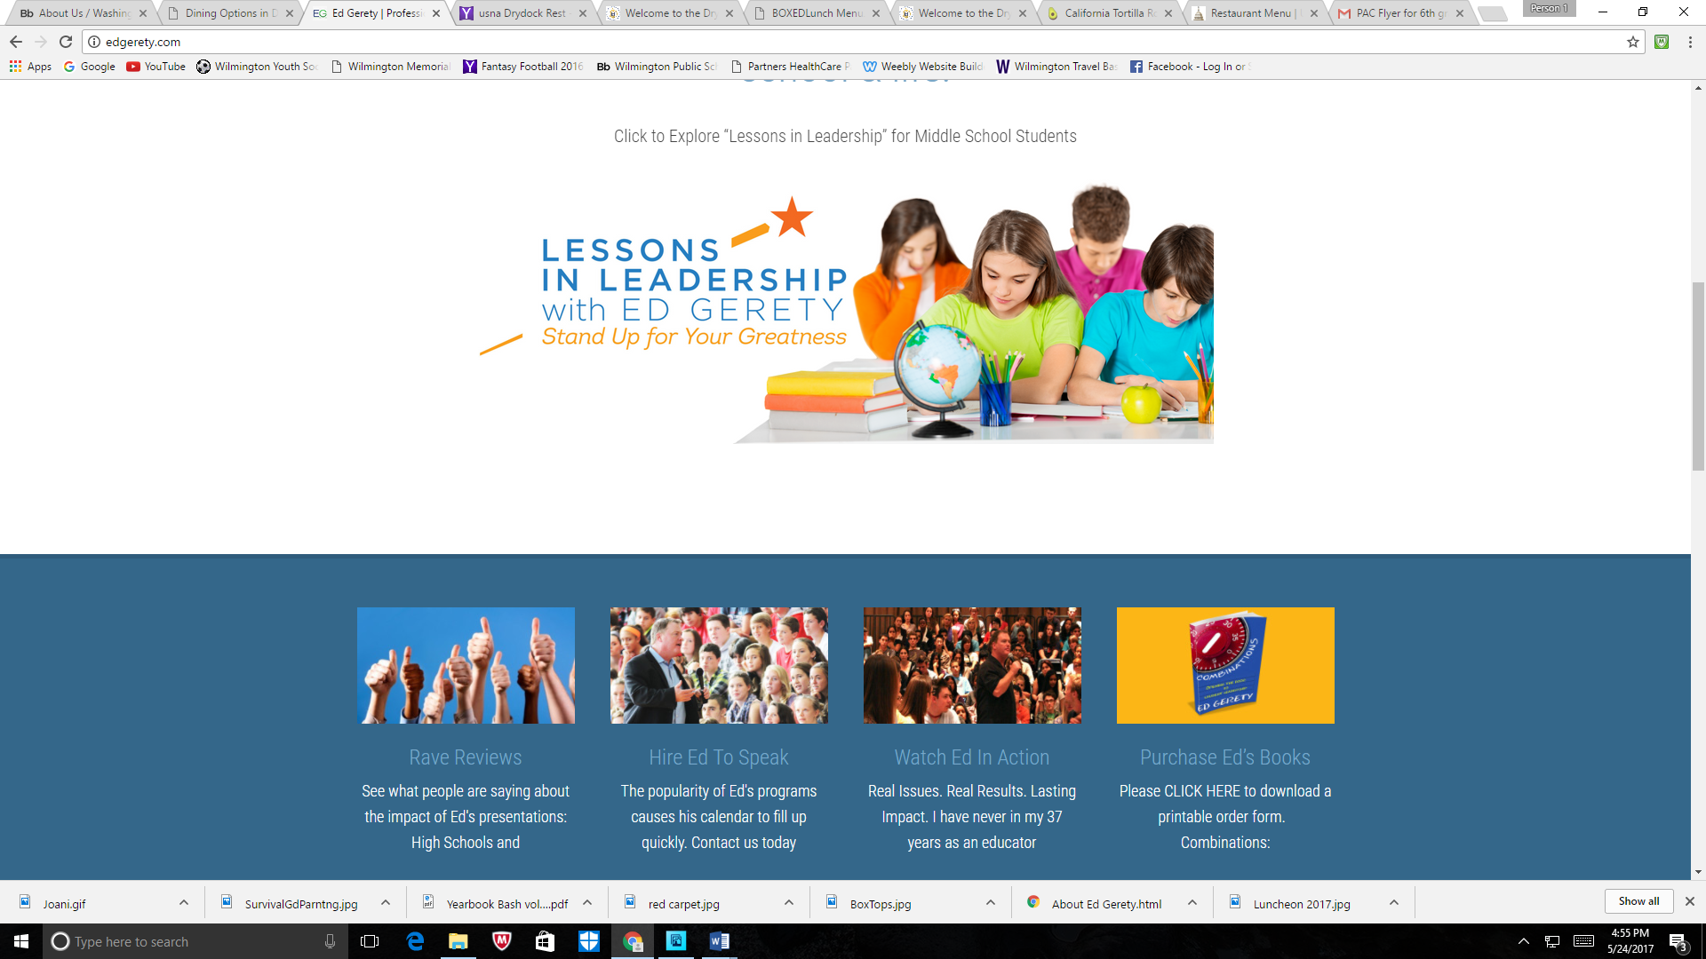

**Motivational Speaker: Ed Gerety**

In December, the PAC hosted motivational speaker,

**Ed Gerety**, to speak to the student body about **leadership** and cultivating a positive school community.

He returned in April for a parent workshop on the same subject. These were both PAC sponsored events.

**HOLIDAY "SWEET TREAT" DAY 2016**

The annual Holiday "Sweet Treat" Day for the Middle School teachers and administrators was held on Wednesday, December 14, 2016 in the teacher's lounge. Each year we designate a day in December to treat our teachers to LOTS of sweets! We also had a fun hot chocolate bar with all the fixings!

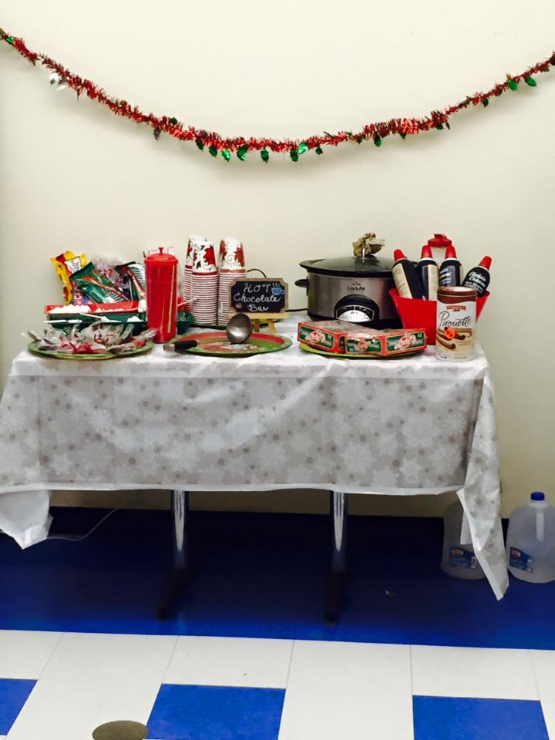 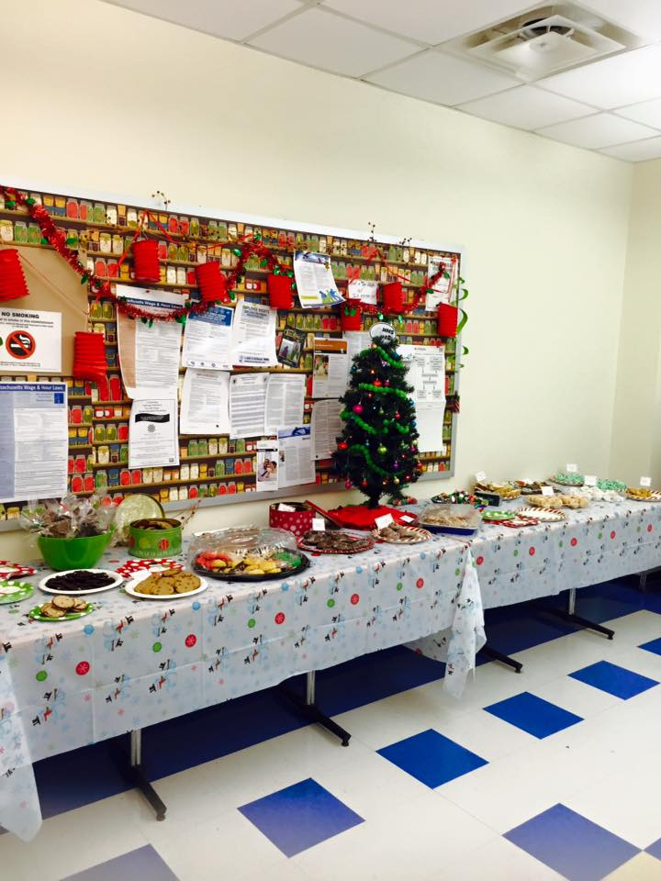

On November 28th the PAC hosted **Joani Geltman** for a parent workshop titled ***“Adolescent Psychology”*** in the Middle School Auditorium.

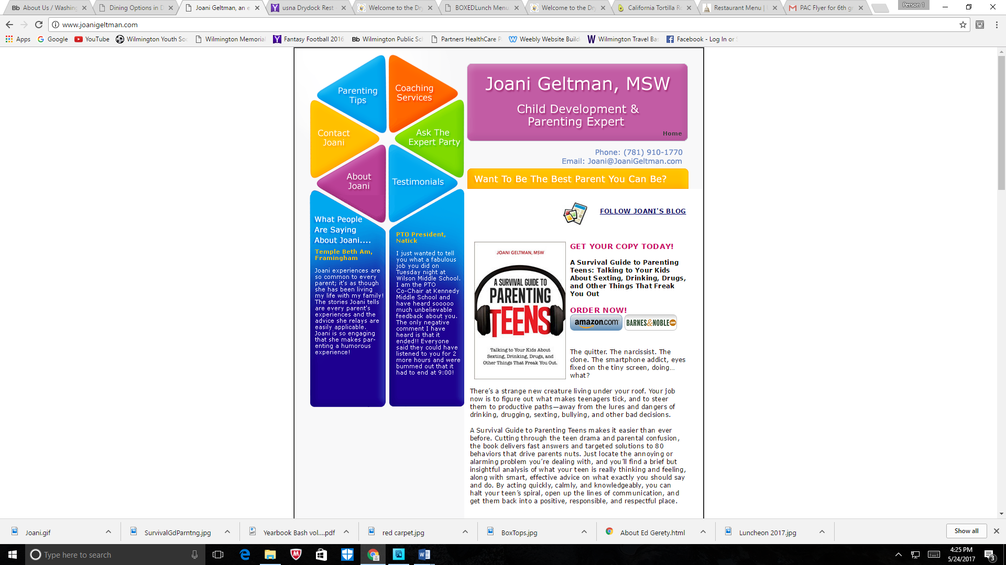 author of: 

The focus of this workshop was to:

* Learn how the brain affects your teen’s behavior. It’s the battle of the thinking brain VS the feeling brain.
* Learn Effective strategies for arguing-The Four Ways Of Fighting.
* Develop effective strategies for keeping your teen safe as they explore the new world of teen life.
* Learn how to teen-proof your home and cell-proof your teen

**TEACHER APPRECIATION LUNCHEON**

On May 12th, in honor of Teacher Appreciation Week, the PAC hosted a “You’re a Star” themed luncheon for all teachers and staff at the Middle School. There is a total of about 110 people who work at the Middle School and we appreciate all their hard work throughout the school year.

When your child moves on to the Middle School one of the biggest changes they experience is going from having one or two teachers to having an average of thirteen different teachers in a school year. It becomes more difficult for parents to show the teachers how much you appreciate their hard work throughout the year. The PAC hosts events during the year to help show our appreciation for all the Middle School teachers and Staff.

# **School Year 2016-2017**

This year was the second year with utilizing our Direct Donation Campaign as the sole way to raise funds. It went very well, thanks to all our generous parents and guardians, and we could provide the school with enrichments and support. Below is a quick summary of some of this year’s accomplishments.



For Field Day in June, the PAC will sponsor the Kona Ice Truck as a treat to the 6th and 7th Grade students. Hoping for good weather!