Wilmington Middle School PAC

|  |  |
| --- | --- |
|  |  |

**What is the WMS PAC?**

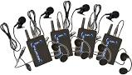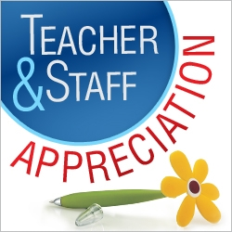

CURRICULUM ENHANCEMENTS (the PAC purchased the following):

* 8th grade student novels, "I AM THE CHEESE"- 90 novels
* 7th and 8th grade Italian curriculum enrichment items (such as games, books, DVDs for students)
* 8th grade Science curriculum enrichment lesson planning books
* 6th grade Science Fair supplies and refreshments for parents
* Tech Ed supplies for curriculum

BUILDING IMPROVEMENTS:

* Retractable belt Sentry Stanchions - Security barriers for the main office hallway
* Bose PA Speaker System for the school
* Worked to complete the Safety Buckets



**ICE CREAM SOCIAL**

The PAC sponsors an Ice Cream Social for the upcoming 6th graders. This is held at the end of the summer on the night of the 6th grade orientation.

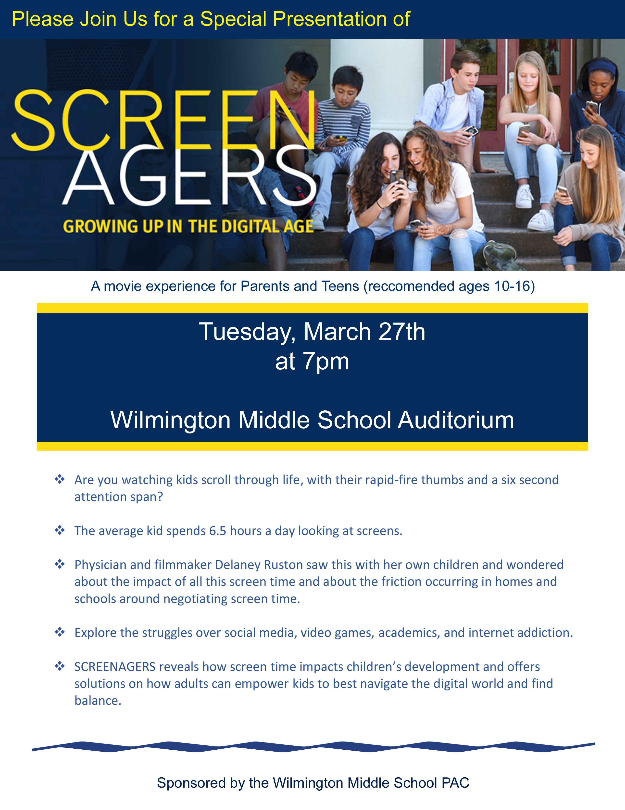

On March 27th, 2018, the PAC hosted a showing of the video Screenagers for all interested students and their parents or guardians.

On May 11th, in honor of Teacher Appreciation Week, the PAC hosted a “50’s” themed luncheon for all teachers and staff at the Middle School. There is a total of about 110 people who work at the Middle School and we appreciate all their hard work throughout the school year.

The PAC provides slush and supplies for the student’s end of the year Field Day. celebration.

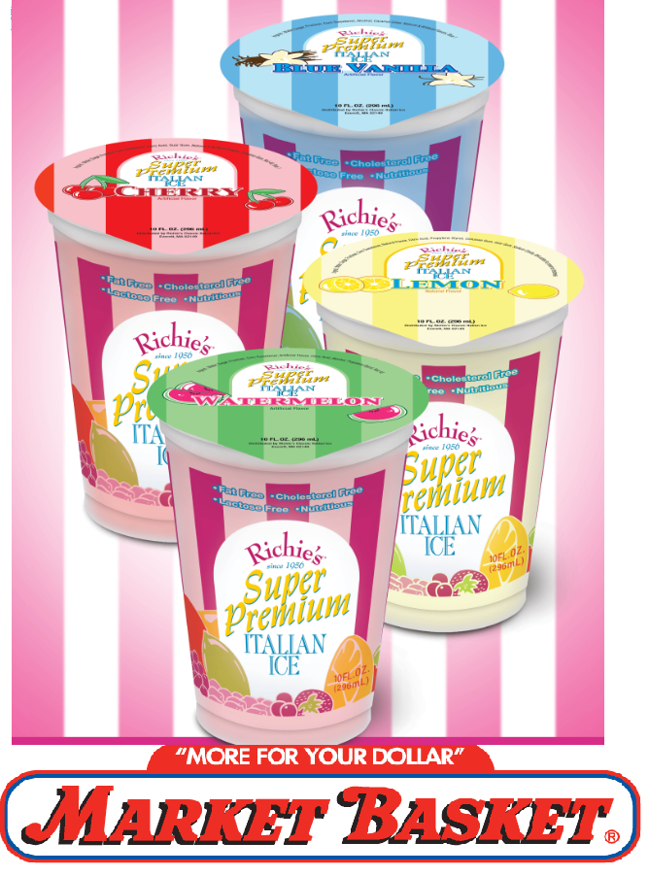

**FIELD DAY!**

**TEACHER APPRECIATION LUNCHEON**

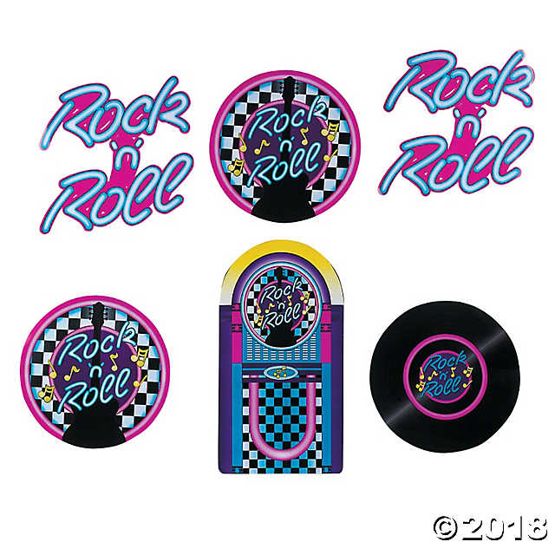

Every parent or guardian of a Middle School student is already a member of the PAC (Parent Advisory Council) and you can be as involved as you wish. The PAC is a fun, relaxed and comfortable atmosphere in which we will discuss important and current school events, issues, programs and fundraisers. All funds raised help to support student enrichment, parent workshops, staff appreciation events, as well as various other school needs like supplies and technology. This year the PAC used a direct donation campaign as the sole means of fundraising. This quick and easy (either online or by check) way to donate hopefully eliminated some of the stress of catalog fundraising and provided parents with an easy way to give back to the schools. Please visit the school website, the Wilmington Middle School PAC page on Facebook, or email ***wilmMSPAC@gmail.com*** for more details.

**HOLIDAY "SWEET TREAT" DAY 2017**

The annual Holiday "Sweet Treat" Day for the Middle School teachers and administrators was held on Thursday, December 14, 2017 in the teacher's lounge. Each year we designate a day in December to treat our teachers to LOTS of sweets! We also had a fun hot chocolate bar with all the fixings!

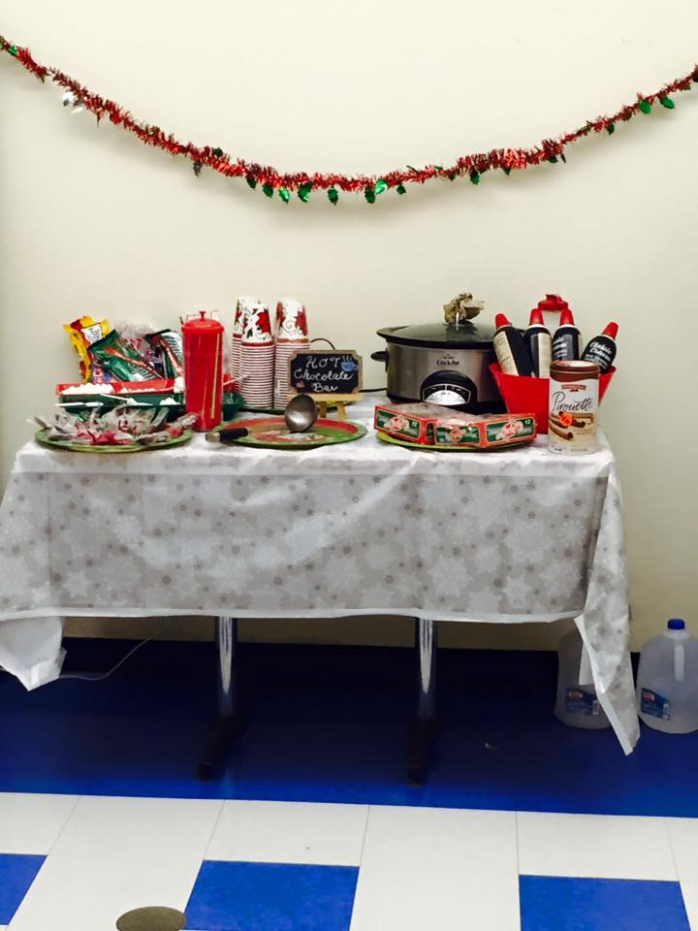 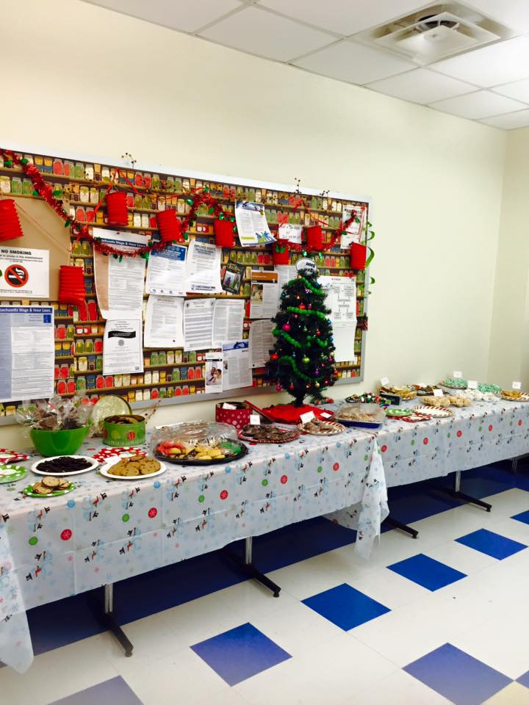

When your child moves on to the Middle School one of the biggest changes they experience is going from having one or two teachers to having an average of thirteen different teachers in a school year. It becomes more difficult for parents to show the teachers how much you appreciate their hard work throughout the year. The PAC hosts events during the year to help show our appreciation for all the Middle School teachers and Staff.

# **SCHOOL YEAR 2017-2018**

This year was the third year utilizing our Direct Donation Campaign as the sole way to raise funds. It went very well, thanks to all our generous parents and guardians, and we could provide the school with enrichments and support. Below is a quick summary of some of this year’s accomplishments.

For Field Day in June, the PAC will sponsor the Kona Ice Truck as a treat to the 6th and 7th Grade students. Hoping for good weather!