Wilmington Middle School PAC

|  |  |
| --- | --- |
|  |  |

**What is the WMS PAC?**

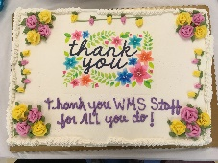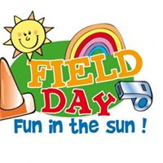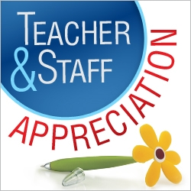



PAC helped sponsor an in-school presentation by Ryan Haack: *“an author, blogger, speaker, and dad. Oh, and I have one hand. I’ve created a program called:****Different Is Awesome! Acknowledging, Accepting and Celebrating What Makes Us Unique!****”*

On May 10th, in honor of Teacher Appreciation Week, the PAC hosted a Spring themed luncheon for all staff at the Middle School. There is a total of approximately 120 people who work at the Middle School and we appreciate all their hard work throughout the school year.

The PAC ran an apparel sale in the fall and spring to inspire school spirit. Staff, students and families could all order Wildcat themed apparel and gear.

BUILDING IMPROVEMENTS:

The PAC is sponsoring an initiative led by Dr. Quirk, Vice Principal at the Middle School, to improve the school bathrooms. She will be painting the walls and doors and doing murals with inspirational quotes to improve the school environment and promote a positive school culture.

CURRICULUM ENHANCEMENTS (the PAC purchased the following):

* 7th grade student novels, "I AM MALALA"
* 6th grade student novels, “WONDER”



# **SCHOOL YEAR 2018-2019**

This year was the fourth year utilizing our Direct Donation Campaign as the sole way to raise funds. It went very well, thanks to all our generous parents and guardians, and we could provide the school with enrichments and support. Below is a quick summary of some of this year’s accomplishments.

When your child moves on to the Middle School one of the biggest changes that they experience is going from having one or two teachers to having an average of thirteen different teachers in a school year. It becomes more difficult for parents to show the teachers how much you appreciate their hard work throughout the year. The PAC hosts events during the year to help show our appreciation for all the Middle School teachers and Staff.

**ICE CREAM SOCIAL**

The PAC sponsors an Ice Cream Social for the incoming sixth graders. This is held at the end of the summer on the night of the sixth-grade scavenger hunt.

**TEACHER APPRECIATION LUNCHEON**

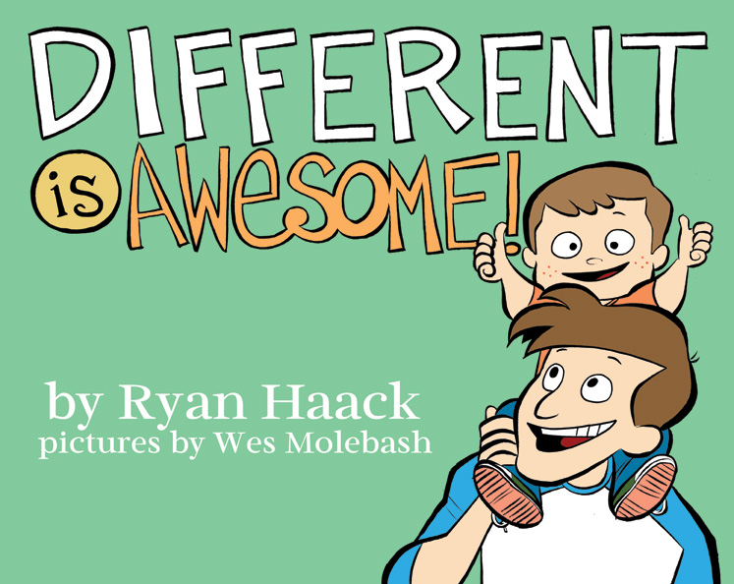

The PAC provides slush and supplies for the student’s end of the year Field Day. celebration.

Every parent or guardian of a Middle School student is already a member of the PAC (Parent Advisory Council) and you can be as involved as you wish. The PAC is a fun, relaxed and comfortable atmosphere in which we will discuss important and current school events, issues, programs and fundraisers. All funds raised help to support student enrichment, parent workshops, staff appreciation events, as well as various other school needs like supplies and technology. This year the PAC used a direct donation campaign as the sole means of fundraising. This quick and easy (either online or by check) way to donate hopefully eliminated some of the stress of catalog fundraising and provided parents with an easy way to give back to the schools. Please visit the school website, the Wilmington Middle School PAC page on Facebook, or email ***wilmMSPAC@gmail.com*** for more details.

**HOLIDAY "SWEET TREAT" DAY**

The annual Holiday "Sweet Treat" Day for the Middle School Staff was held on Friday, December 14, 2018 in the teacher's lounge. Each year we designate a day in December to treat our teachers to LOTS of sweets! We also had a fun, hot chocolate bar with all the fixings!

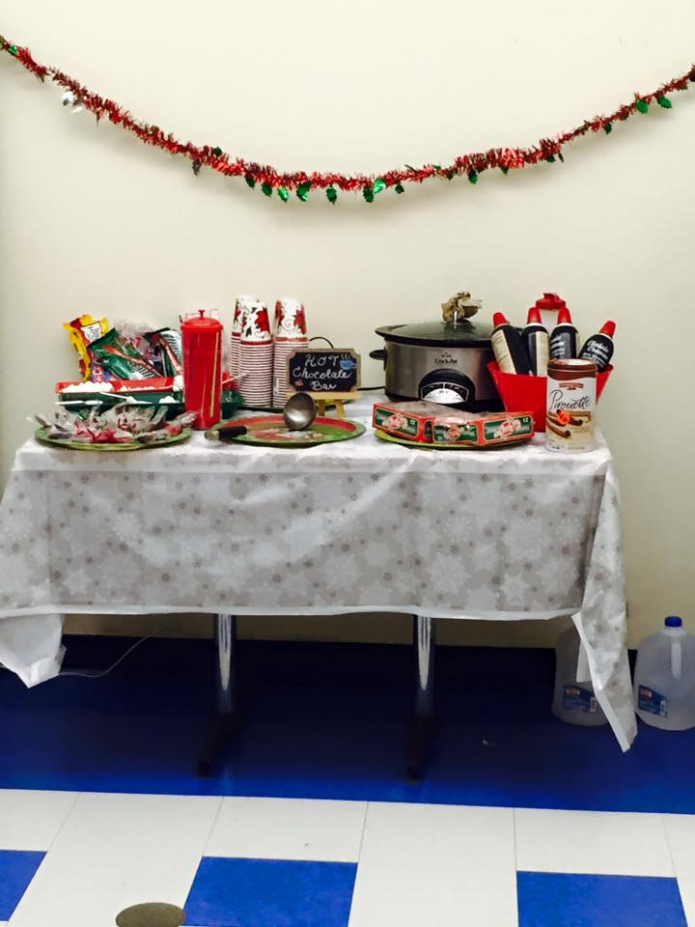 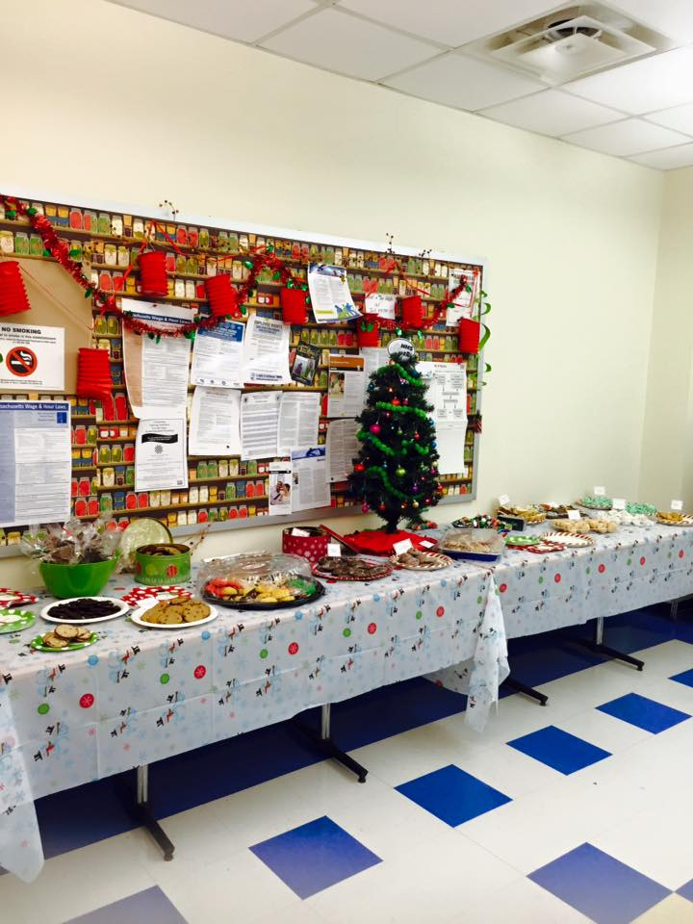

For Field Day in June, the PAC will sponsor the Kona Ice Truck as a treat to the 6th and 7th Grade students. Hoping for good weather!