Wilmington Middle School PAC Meeting
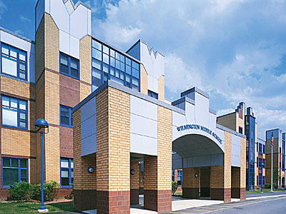
Agenda
~ January 22nd, 2018 @6:00pm ~
2017-2018 PAC Officers
Lynne Parr – President - lpcp95@verizon.net
Maryellen Dugan - Vice President - medugan11@verizon.net
Rhonda Rubin – Treasurer – jrrubin34@comcast.net
Jessica Bourgeois – Secretary – bourgeoisjess@gmail.com
- Welcome

- Principal’s Report – Mr. Welch
  - Brief update on the progressing school year and upcoming events

PAC Business:
- Treat Fest Recap
- Any input from district on hosting the film Screenagers-March?
- Superintendent Search
- Any other new ideas for upcoming student assemblies, parent workshops, teacher wish lists etc. for the 2017-2018 school year?
- Approve any additional requests-need input
- Box Top Contest Collection-participation? prize?
- Treasurer’s Report

The next PAC Meeting will be held on Monday, February 12th, 2018 at 6:00pm

