Wilmington Middle School PAC Meeting
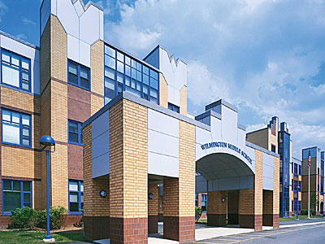
Agenda
~ -February 25th, 2019 @6:00pm ~
2018-2019 PAC Officers
Heather Long - President – heatherdlong77@gmail.com
Maryellen Dugan - Vice President - medugan11@verizon.net
Lynne Parr – Treasurer – lpcp95@verizon.net
Jessica Bourgeois – Secretary – bourgeoisjess@gmail.com
- Welcome

- Principal’s Report – Mr. Welch
  - Brief update on the progressing school year and upcoming events

PAC Business:
- Treasurer’s Report
- Apparel Sales update
- Box Tops update
- Holiday Treat Fest update
- Rob Surette Enrichment
- Upcoming Ryan Haack, author of Different is Awesome enrichment event. Does school need funding request?
- Any additional new funding requests from Middle School?
- Voice any ideas that members would like passed on to the Strategic Plan committee working with the Superintendent
- Dining for a Cause at the 99?

The next PAC Meeting will be held on Monday, March 25, 2019 at 6:00pm

