Wilmington Middle School PAC Meeting
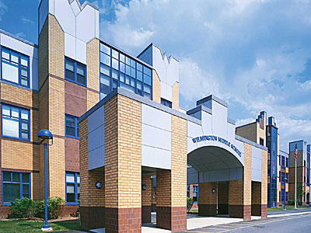
Agenda
~ October 23rd, 2017 @6:00pm ~
2017-2018 PAC Officers
Lynne Parr – President - lpcp95@verizon.net
Maryellen Dugan - Vice President - medugan11@verizon.net
Rhonda Rubin – Treasurer – jrrubin34@comcast.net
Jessica Bourgeois – Secretary – bourgeoisjess@gmail.com
- Welcome

- Principal’s Report – Mr. Welch
  - Brief update on the progressing school year and upcoming events
  - Update on Sub-Committee progress for 8th grade Field Trip
  - Status of the SAC
PAC Business:
- New Ideas
  - Hosting an evening viewing of the film Screenagers by physician and filmmaker Delaney Ruston (please go to www.screenagersmovie.com to view trailer)
  - Hosting motivational speaker Todd Waites? He will be presenting at the Shawsheen and West on February 5th. “Todd has a passion to help people of all ages develop a positive self-perception and learn to accept others just the way they are.” Todd Waites is an arm amputee, cancer survivor, executive, musician and motivational speaker. Website www.toddwaites.com
  - All You Got Tour focuses on young musicians and artists while fighting against the current opioid crisis in New England-go to www.allyougottour.com
    - “Patty Duffey, President of the Young Performers Club, and Jackie LoGiudice, President of Next Generations Concerts, created the tour based on their dedication to showcase talented and hard-working 21 and under youth musicians to provide them unique opportunities to demonstrate their love of music and performing to engaging audiences. The tour shows will be a powerful mix of the arts along with influential speakers passionate about important social issues; anti-bullying and youth drug prevention.”
  - Any other new ideas for upcoming student assemblies, parent workshops, teacher wish lists etc. for the 2017-2018 school year?
- Approve funds to host author, Yoko Kawashima Watkins, who wrote the book, So Far From The Bamboo Grove.
- Status of Direct Donation Fundraiser
- Treasurer’s Report
- Box Tops Contest status
- School Store- Open on November 3rd approve funds for purchasing supplies

Next PAC Meeting will be held on Monday, November 13th, 2017 at 6:00pm

