Wilmington Middle School PAC Meeting
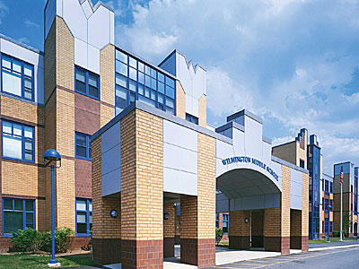
Agenda
~ November 13th, 2017 @6:00pm ~
2017-2018 PAC Officers
Lynne Parr – President - lpcp95@verizon.net
Maryellen Dugan - Vice President - medugan11@verizon.net
Rhonda Rubin – Treasurer – jrrubin34@comcast.net
Jessica Bourgeois – Secretary – bourgeoisjess@gmail.com
- Welcome

- Principal’s Report – Mr. Welch
  - Brief update on the progressing school year and upcoming events

PAC Business:
- PAC will host the annual Holiday Treat Fest on December 14th, 2017 for all staff (approximately 120 people)
- Any input from district on hosting the film Screenagers, hosting motivational speaker Todd Waites or the All You Got Tour?
- Any other new ideas for upcoming student assemblies, parent workshops, teacher wish lists etc. for the 2017-2018 school year?
- Status of Direct Donation Fundraiser
  - Provides the Budget for the following:
    - School Store Operation
    - Holiday Treat Fest-December
    - Teacher Luncheon-Late Spring
    - 6th and 7th Grade Field Day-Kona Ice-June
    - Photo Booth-8th grade semi-formal-June
    - Ice Cream Social Orientation-summer
    - All additional teacher/administration requests-need input
- Approve money for store-vote
- Approve money for visiting author (amount??)-vote
- Box Top Contest Collection
- Treasurer’s Report

There will be no December meeting due to school vacation week. The next PAC Meeting will be held on Monday, January 22nd, 2018 at 6:00pm

