Wilmington Middle School PAC Meeting
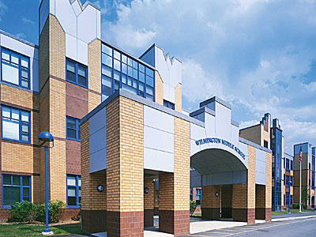
Agenda
~ November 26th, 2018 @6:00pm ~
2018-2019 PAC Officers
Heather Long - President – heatherdlong77@gmail.com
Maryellen Dugan - Vice President - medugan11@verizon.net
Lynne Parr – Treasurer – lpcp95@verizon.net
Jessica Bourgeois – Secretary – bourgeoisjess@gmail.com
- Welcome

- Principal’s Report – Mr. Welch
  - Brief update on the progressing school year and upcoming events

PAC Business:
- Treasurer’s Report
  - Finalize this year’s budget
- Upcoming Holiday Treat Fest
  - Will be held on December 14th, 2018
  - Need volunteers to help solicit donations and pick them up on or before the Treat Fest. Possible donators: Panera, La Cascia's Bakery, Heavenly Donuts, La Rosas', and Edible Arrangements (they are already donating - Lynne will pick up arrangement)
- New Funding Requests from Middle School:
  - Funding Requests to spend money for Wonder Books (30 book needed) - Amazon $9.20 per book ($276) and I am Malala Books - paperback (90 books for $891.00)
- Middle School Principal Search
- Review and Approve PAC Bylaws and Conflict of Interest Policy
- Tax Status

The next PAC Meeting will be held on Monday January 28, 2018 at 6:00pm

