Wilmington Middle School PAC Meeting
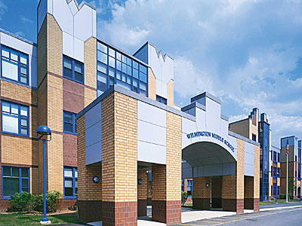
Agenda
~ February 26th, 2018 @6:00pm ~
2017-2018 PAC Officers
Lynne Parr – President - lpcp95@verizon.net
Maryellen Dugan - Vice President - medugan11@verizon.net
Rhonda Rubin – Treasurer – jrrubin34@comcast.net
Jessica Bourgeois – Secretary – bourgeoisjess@gmail.com
- Welcome

- Principal’s Report – Mr. Welch
  - Brief update on the progressing school year and upcoming events

PAC Business:
- Treasurer’s Report
- Screenagers- March 27th (where?, what time?)
- Superintendent Search Completed
- Any other new ideas for upcoming student assemblies, parent workshops, teacher wish lists etc. for the 2017-2018 school year?
- PAC Tax Exempt Status
- Review By-Laws (approve updates at next meeting?)

The next PAC Meeting will be held on Monday, February 12th, 2018 at 6:00pm

