Wilmington Middle School PAC Meeting
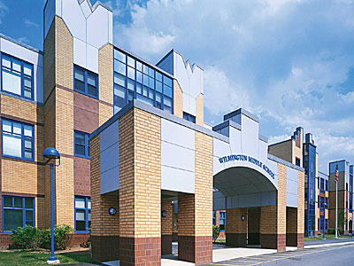
Agenda
~ March 20, 2016 @6:30pm ~

2015-2015 PAC Officers
Lynne Parr – President - lpcp95@verizon.net
Tricia Brisbois - Vice President - triciabrisbois@yahoo.com
Rhonda Rubin – Treasurer – jrrubin34@comcast.net
Jessica Bourgeois – Secretary – bourgeoisjess@gmail.com

- Principal’s Report – Mr. Welch
- Treasurer’s Report – Rhonda R.

Updates:
- Box Tops Contest Submissions due April 13th
- New prize ideas?
- Use of Box Tops funds from first submission ($425) to go to Ed Gerety Parent Night
- Teacher Luncheon May 12th
- Field Day Kona Ice for 6th and 7th graders-vote on funds
- Photo Booth at Semi-Formal (date?) for 8th graders-vote on funds
- Website
- End of Year PAC Newsletter for parents?

Feel free to email any member of the PAC with ideas/comments
Next PAC Meeting is Monday, May 15, 2017 at 6:30 pm in the Middle School Library
WMS PAC email address: WilmMSPAC@gmail.com
Find The WMS PAC on FaceBook and “LIKE” our page to stay informed.
Let’s work together to build a better future for our children…

