Wilmington Middle School PAC Meeting
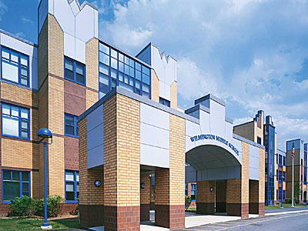
Agenda
~ March 25th, 2019 @6:00pm ~
2018-2019 PAC Officers
Heather Long - President – heatherdlong77@gmail.com
Maryellen Dugan - Vice President - medugan11@verizon.net
Lynne Parr – Treasurer – lpcp95@verizon.net
Jessica Bourgeois – Secretary – bourgeoisjess@gmail.com
- Welcome

- Principal’s Report – Mr. Welch
  - Brief update on the progressing school year and upcoming events

PAC Business:
- Treasurer’s Report
- Box Tops update
- Upcoming Teacher Luncheon
- Kona Ice/Slush for Field Day?
- Any additional new funding requests from Middle School?
- Open PAC board positions for school year 2019-2020

The next PAC Meeting will be held on Monday, April 29, 2019 at 6:00pm

