Wilmington Middle School PAC Meeting
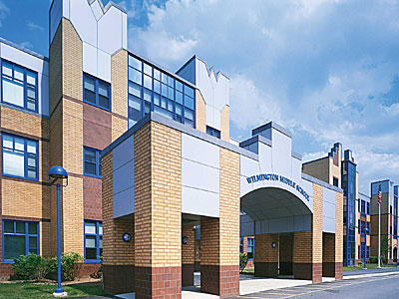
Agenda
~ April 27, 2016 @6:30pm ~
2015-2015 PAC Officers
Lynne Parr – President - lpcp95@verizon.net
Tricia Brisbois - Vice President - triciabrisbois@yahoo.com
Rhonda Rubin – Treasurer – jrrubin34@comcast.net
Jessica Bourgeois – Secretary – bourgeoisjess@gmail.com

- Principal’s Report – Ms. Gerade/Mr. Sheehan/Mr. O’Brien
- Treasurer’s Report – Rhonda R.

Updates:
- Tax Form Reinstatement Status
New Business:
- Purchase of Math Calculators for MCAS
- Website Update
- Upcoming Teacher Appreciation Luncheon
- Field Day Plans

Feel free to email any member of the PAC with ideas/comments
Next PAC Meeting is Thursday, May 12, 2016 at 8:30 am in the Middle School Library
WMS PAC email address: WilmMSPAC@gmail.com
Find The WMS PAC on FaceBook and “LIKE” our page to stay informed.
Let’s work together to build a better future for our children…

