Wilmington Middle School PAC Meeting
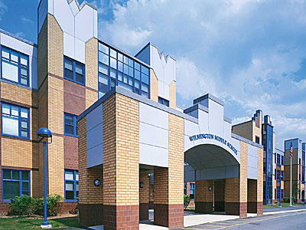
Agenda
~ April 30th, 2018 @6:00pm ~
2017-2018 PAC Officers
Lynne Parr – President - lpcp95@verizon.net
Maryellen Dugan - Vice President - medugan11@verizon.net
Rhonda Rubin – Treasurer – jrrubin34@comcast.net
Jessica Bourgeois – Secretary – bourgeoisjess@gmail.com
- Welcome

- Principal’s Report – Mr. Welch
  - Brief update on the progressing school year and upcoming events

PAC Business:
- Teacher Luncheon
- Funding Requests
- Screenagers Recap
- Box Top Collection
- Treasurer’s Report
- Next Year’s Open Positions

The next PAC Meeting will be held on Monday, May 21st, 2018 at 6:00pm

