Wilmington Middle School PAC Meeting
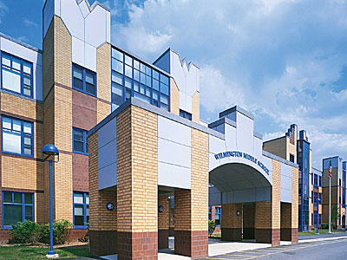
Agenda
~ May 15th, 2017 @6:30pm ~
2015-2015 PAC Officers
Lynne Parr – President - lpcp95@verizon.net
Tricia Brisbois - Vice President - triciabrisbois@yahoo.com
Rhonda Rubin – Treasurer – jrrubin34@comcast.net
Jessica Bourgeois – Secretary – bourgeoisjess@gmail.com

- Principal’s Report – Mr. Welch
- Treasurer’s Report – Rhonda R.

Updates:
- 2016-2017 PAC Recap
  - Any issues or possible improvements?
  - Open Board positions-elections

- Tax Form Reinstatement Status
Upcoming Business:
- Website update
- End of Year Newsletter
- Field Day
- 8th Grade Semi-Formal Photo Booth
- Final BoxTops Collection and Prize- June 2nd

Feel free to email any member of the PAC with ideas/comments
Next PAC Meeting will be held in September of 2017
WMS PAC email address: WilmMSPAC@gmail.com
Find The WMS PAC on FaceBook and “LIKE” our page to stay informed.
Let’s work together to build a better future for our children…

