Wilmington Middle School PAC Meeting
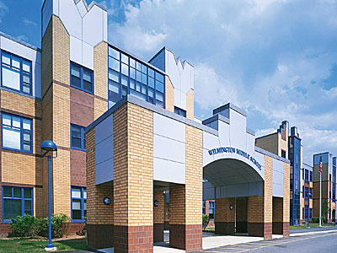
Agenda
~ May 20th, 2019 @6:00pm ~
2018-2019 PAC Officers
Heather Long - President – heatherdlong77@gmail.com
Maryellen Dugan - Vice President - medugan11@verizon.net
Lynne Parr – Treasurer – lpcp95@verizon.net
Jessica Bourgeois – Secretary – bourgeoisjess@gmail.com
- Welcome

- Principal’s Report – Mr. Welch
  - Brief update on the progressing school year and upcoming events

PAC Business:
- Treasurer’s Report
- Teacher Luncheon Re-cap
- Box Tops Update
- Spring Apparel Sale Update
- Bathroom Painting Timeline?
- Any additional new funding requests from Middle School?
  - Google forms response?
  - Mr. Welch’s book request for 6th grade-need details
- Open PAC board positions for school year 2019-2020
  - Voting

The next PAC Meeting will be held on Monday, June 10, 2019 at 6:00pm

