Wilmington Middle School PAC Meeting
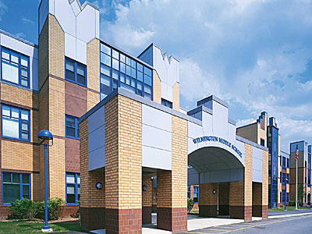
Agenda
~ October 29th, 2018 @6:00pm ~
2017-2018 PAC Officers
– President -
Maryellen Dugan - Vice President - medugan11@verizon.net
Lynne Parr – Treasurer – lpcp95@verizon.net
Jessica Bourgeois – Secretary – bourgeoisjess@gmail.com
- Welcome

- Principal’s Report – Mr. Welch
  - Brief update on the progressing school year and upcoming events

PAC Business:
- Open Positions on the PAC
  - Vote on new President
- Treasurer’s Report
- Upcoming Holiday Treat Fest
  - Decide on date
  - Manage donations
- New SAC formation (Robyn Matzke, Barbara Sica)
- New Funding Requests from Middle School

The next PAC Meeting will be held on Monday, November 26th, 2018 at 6:00pm

